Machine Learning Types ->

1. Supervised Machine Learning ( you have historical input output and machine is trained on this data)

(most of the ml is sml)

Two parts sml---------🡪 Regression

------🡪 Classification

Data of two type – numerical (age ,weight , cgpa)

Categorical (gender ,nationality)

Regression: if output of the supervise ml is numerical

Example: iq cgpa package ( 7.8 , 19, 7)

Classification: output col is categorical ( yes/ no , gender etc.)

Regression problem: cost prediction

Classification: Image detection.

Summary: Output is the key

2. Unsupervised Machine Learning (suppose data like iq and cgpa are give of 5000 students, no output is given so we don’t what to predict)

Four things in unsupervised machine learning (use cases)----🡪 Clustering, Dimensionally Reduction , Anamoly Detection, Association Rule Learning

Clustering Algo can detect groups of input pair (iq,cgpa) group from graphs. After clustering we can create output for out supervised ml. Very powerful technique.

Sometimes we will have way too many inputs column. Risk of running slow, some col are useless. Dim reduction will remove extra column. Dim reduction will reduce (no of rooms, no of washroom) to just square feet for better organization.

ARL scanning bills of supermarket to find association of let’s say milk and water. Then sort the equipment together. Example keep diaper and beer together data shows they are brought together.

3. Semi supervised 🡪 instead of manually labelling everything manually. Creating output col is hard and costly. So in this we label two or three data points then the machine starts from there . Google photos

4. Reinforcement Learning: Agents are deployed in situations.Like self driving car, teaching dogs. We use unsupervised to first find the labels. We don’t give data to machine here. It learns from the basic by making mistakes.

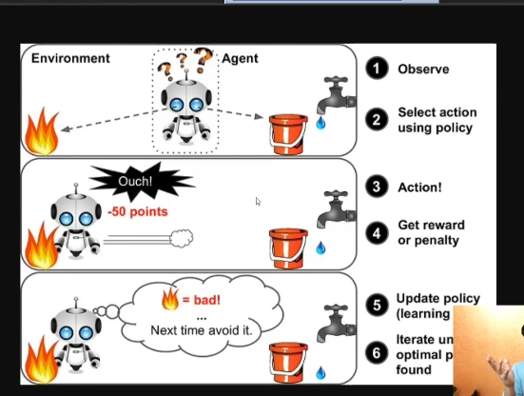

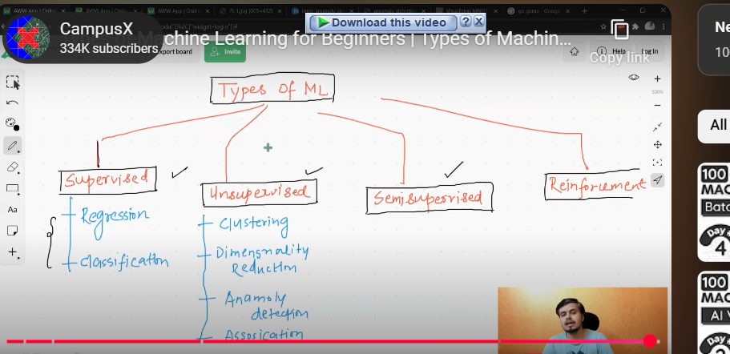

**Day 4**: Offline vs online Learning

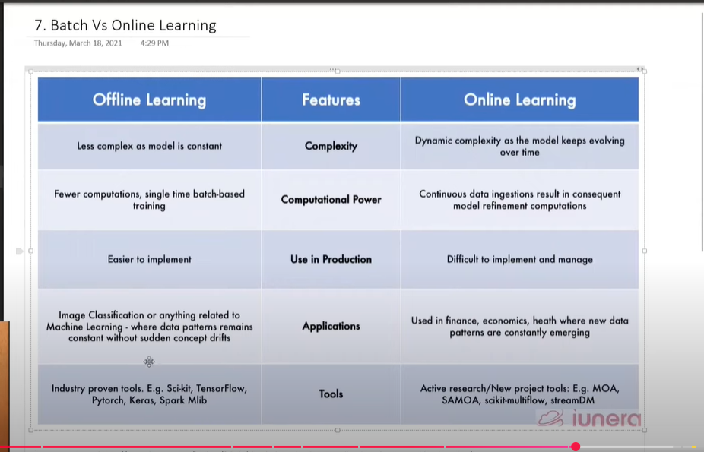

**Day 6:** Instance vs model-based learning

**Day 7:** Challenges in machine learning (building a model to deploying it), MLOPS (machine learning operations)

**Day 8:** Applications of machine learning

**Example 1**: Retail – Amazon/Big Bazaar

Do we stock each product??

Giving Mobile Numbers: They create profiles of their customers depending on their buys. Then they sell these data to other companies. So, we get messages from random numbers.

**Example 2:** Banking and finance

* They don’t give loans to everyone. They assess your profile and based on that check if your kind pays back the loan

**Example 3:** Transportation

* Fare is higher at times for uber

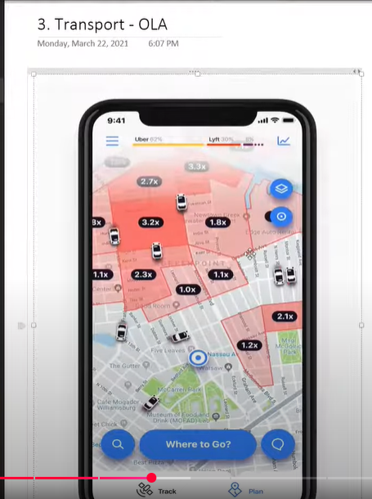

* At noon demand becomes high and so you give extra money and take that money from customers
* Cabs fare during puja

**Example 4:** Used in maintenance

**Example 5:** Consumer Internet – Twitter

Twitter made a plan and started sentiment analysis (used in NLP)

15000 tweets, out of them let’s say 60% says Donald trump is winning. So, twitter can sell them to stock brokers. This company can invest on products that can help them.

**Day 9:** MLDLC

* Frame the problem: What problem overall idea
* Gathering Data: Hard at industry level. I used chess.com api to get my data about the games
* Data Preprocessing: Garbage in garbage out. Remove the duplicate games, missing values, outliers, scale the values
* Exploratory Data Analysis: Understand the relation between data, Graphs and other things. Column wise analysis
* Feature engineering and selection: Feature means input columns.
* Model Training, Evaluation and Selection: Use every ml algo to find which works the best.
* Model Deployment: Convert it into a interface. Binary file 🡪 API(URL that returns JSON object)🡪 Python App

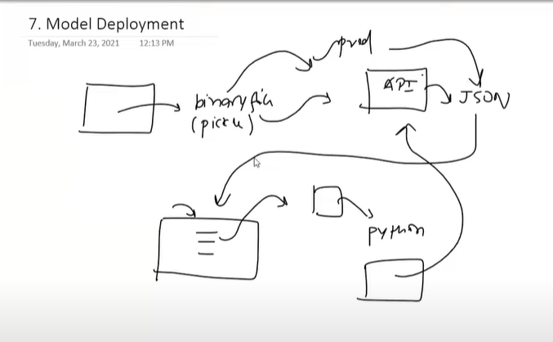

* Testing:
* Optimize: Backup, rollback and other stuff

**Day 10:** Job types and comparison (skipped for now)

Day 11: Tensor?? What are tensors

Tensor is a data structure. It’s a container that stores numbers, strings (rarely). N dimensional array is the same as array.

0D tensors: (2) (3) scalars. This means number of dimensions is zero.

Day 13: Logistic Regression , Draws a line.

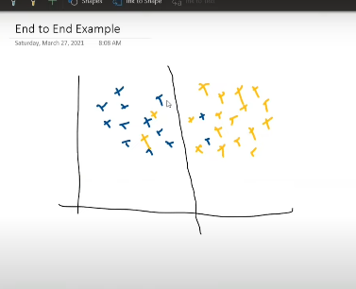

**Day 14:** Churn Rate : How many drop offs of users in Netflix or industry